Final Test [Unit 5-8] Name: Score: /100

◈ Complete the sentences using the phrases in the box. (3 points each)
music producer pour ski suit onion modern mask

1. | 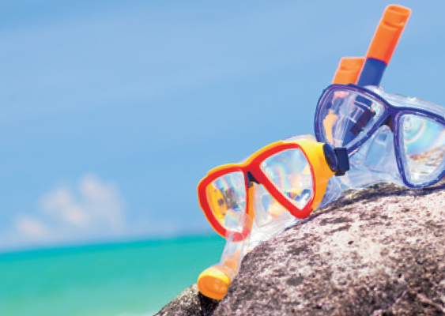 | We want to go snorkeling, so I will pack my __________________ and snorkel.
2. | 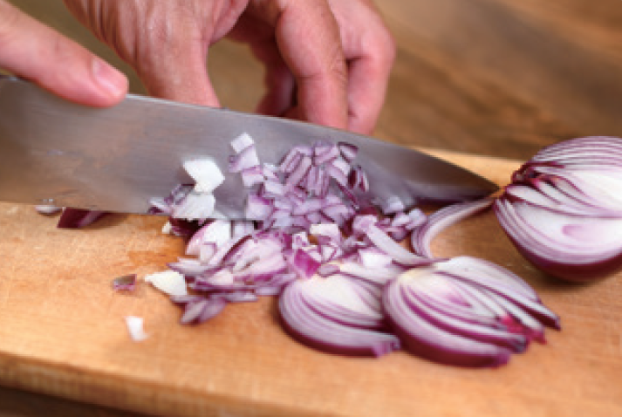 | Wash and chop the ___________________.
3. | 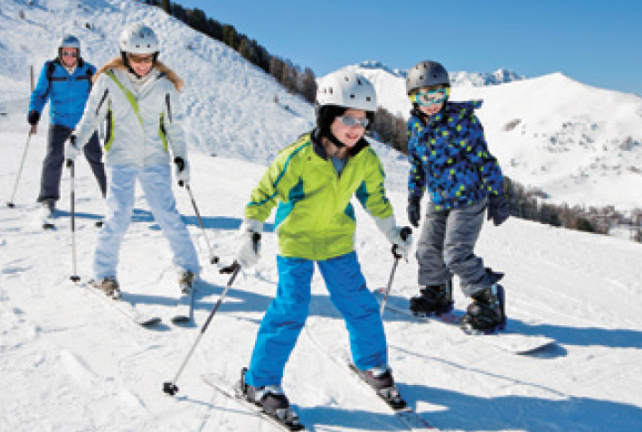 | I will pack my skis and a __________________.
4. | 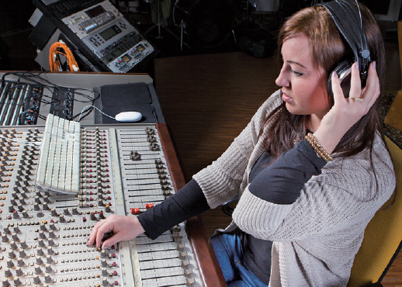 | I am sure I will be a great ___________________ one day.
5. | 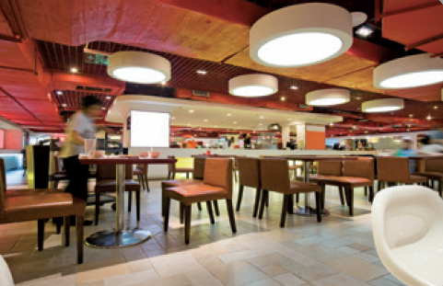 | This restaurant has a ___________________ atmosphere.
6. | 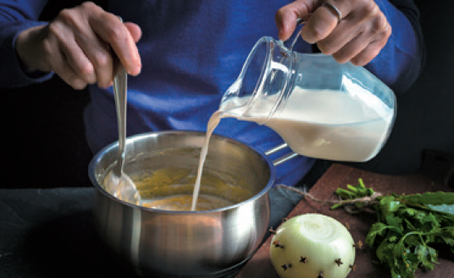 | ___________________ the milk in a large pot.

◈ Circle the correct words. (3 points each)
7. (If / Then) I become a makeup artist, I will help celebrities prepare for events.
8. I am (exciting / excited) to eat delicious food.
9. After 5 minutes, put the rice (into / on) the bowl.
10. I liked the lamb steak (least / the least).
11. The service was not that (good / best) overall.
12. Police officers are people who (keep / keeps) us safe.

◈ Match the phrases and write the sentences. (4 points each)
13. | I had to wait 30 minutes to get a table, | ∙ | ∙ | very reasonable.
14. | I will pack my snacks | ∙ | ∙ | its one-star rating.
15. | The prices were | ∙ | ∙ | mix the milk and butter.
16. | While you wait, | ∙ | ∙ | to share at night.
17. | The restaurant deserves | ∙ | ∙ | but it wasn’t worth the wait.

___________________________________________________________________________________________
___________________________________________________________________________________________
___________________________________________________________________________________________
___________________________________________________________________________________________
___________________________________________________________________________________________

◈ Put the words in order. (5 points each)
18. (need to / more about / flight / learn / I / safety rules / .)
___________________________________________________________________________________________
19. (Do you / any / plans / have / exciting / this summer / ?)
___________________________________________________________________________________________
20. (The restaurant / atmosphere / Turkish food / and has / serves / a casual / .)
___________________________________________________________________________________________
21. (is / perfect / creative job / A / for me / like this / !)
___________________________________________________________________________________________

◈ Find the mistakes and rewrite the sentences. (6 points each)
22. I had a wonderful experience at a restaurant call Burger Buy.
___________________________________________________________________________________________
23. I am good at play musical instruments and making my own songs.
___________________________________________________________________________________________
24. This holiday season, I am go to go on a cruise.
___________________________________________________________________________________________
25. When I grow up, I want to be baker.
___________________________________________________________________________________________

Final Test [Answer Key]

1. mask
2. onion
3. ski suit
4. music producer
5. modern
6. Pour
7. If
8. excited
9. into
10. the least
11. good
12. keep
13. I had to wait 30 minutes to get a table, but it wasn’t worth the wait.
14. I will pack my snacks to share at night.
15. The prices were very reasonable.
16. While you wait, mix the milk and butter.
17. The restaurant deserves its one-star rating.
18. I need to learn more about flight safety rules.
19. Do you have any exciting plans this summer?
20. The restaurant serves Turkish food and has a casual atmosphere.
21. A creative job like this is perfect for me!
22. I had a wonderful experience at a restaurant called Burger Buy.
23. I am good at playing musical instruments and making my own songs.
24. This holiday season, I am going to go on a cruise.
25. When I grow up, I want to be a baker.

