Mid-Term Test [Unit 1-4] Name: Score: /100

◈ Complete the sentences using the phrases in the box. (3 points each)
chilly rubber left spring advice mug

1. |  | Thank you for giving me ___________________.
2. | 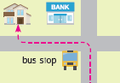 | Turn ___________________ at the bus stop.
3. | 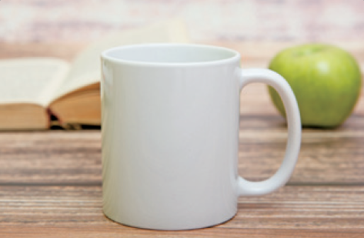 | I am selling my ___________________ for $4.
4. | 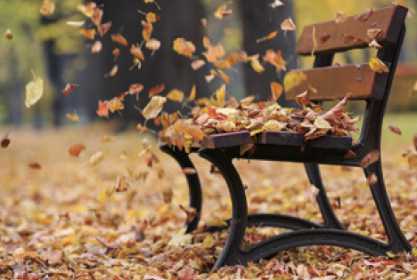 | In fall, it is ___________________ and windy.
5. | 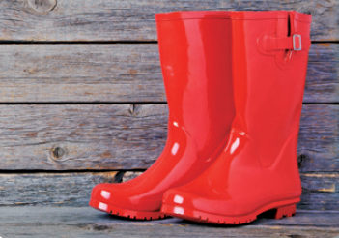 | These rain boots are red and made of ___________________.
6. | 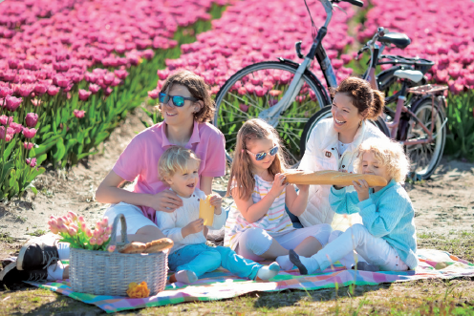 | I like to go on picnics in ___________________.

◈ Circle the correct words. (3 points each)
7. I hate (wear / wearing) thick clothes!
8. The baseball glove has a small tear, but it is (in / on) okay condition.
9. I got (this / these) rain boots recently for $20.
10. Please (bring / brings) a costume and a mask.
11. Thank you for (buy / buying) me a nice jacket last month.
12. Winter is the perfect season (to / for) play in the snow.

◈ Match the phrases and write the sentences. (4 points each)
13. | We will listen to music | ∙ | ∙ | a post office and a school.
14. | Thank you for always | ∙ | ∙ | I wear the hat.
15. | The sunglasses | ∙ | ∙ | and learn dance steps.
16. | You will pass | ∙ | ∙ | have a metal frame.
17. | I will think of you whenever | ∙ | ∙ | telling me funny stories.

___________________________________________________________________________________________
___________________________________________________________________________________________
___________________________________________________________________________________________
___________________________________________________________________________________________
___________________________________________________________________________________________

◈ Put the words in order. (5 points each)
18. (You are / the whole / mom / the greatest / in / world / !)
___________________________________________________________________________________________
19. (your / proud / I am / to be / so / son / .)
___________________________________________________________________________________________
20. (best / the / are / driver / You / ever / .)
___________________________________________________________________________________________
21. (I / because / the sunglasses / never use them / The reason I am selling / is / .)
___________________________________________________________________________________________

◈ Find the mistakes and rewrite the sentences. (6 points each)
22. I have to wear a coats and mittens.
___________________________________________________________________________________________
23. The baseball glove is softly, so you can catch the ball well.
___________________________________________________________________________________________
24. From the subway station, walks straight down Central Avenue.
___________________________________________________________________________________________
25. My house is right across street!
___________________________________________________________________________________________

Mid-Term Test [Answer Key]

1. advice
2. bus stop
3. mug
4. chilly
5. rubber
6. spring
7. wearing
8. in
9. these
10. bring
11. buying
12. to
13. We will listen to music and learn dance steps.
14. Thank you for always telling me funny stories.
15. The sunglasses have a metal frame.
16. You will pass a post office and a school.
17. I will think of you whenever I wear the hat.
18. You are the greatest mom in the whole world!
19. I am so proud to be your son.
20. My house is right across the street!
21. The reason I am selling the sunglasses is because I never use them.
22. I have to wear a coat and mittens.
23. The baseball glove is soft, so you can catch the ball well.
24. From the subway station, walk straight down Central Avenue.
25. My house is right across the street!

